All the testimonials can be verified written by our patients hand at our center.

**What our patients say about us**-

My one of the tooth accidently got fractured when I was on the Taj tour with my large tourist group. I was so scared for the spread of any infection till I reach my country back and get its treatment done. Somebody gave me a very strong suggestion to consult Dr. Ajay. Dr. Ajay explained me all the procedure and suggested to go for its extraction, immediate implant placement and placing a cap on the next day morning. I am still really surprised how nicely he extracted my tooth with his piezo surgery unit, immediately inserted implant and placed the cap before the time he committed. All procedure was done without any pain and swelling. I routinely joined my tour group, had all the food with any discomfort. I consulted my dentist later on and explained all about the implant treatment done by Dr. Ajay and he was really impressed for the procedure done. It has been 4 years and my implant working well. I am sending these comments via mail to Dr. Ajay’s center with lot of thanks to give me better treatment even in a very short span.

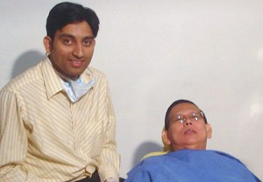 **Mr. V. Ahlad (Malaysia)**

I was fade up with the painful and unsatisfactory dental work done by all of my previous dentists. Somebody referred me to Dr. Ajay’s centre and Dr. Ajay gave me Very beautiful and comfortable metal free ceramic crowns, root canal treatments and dental implant treatment without any pain. Dr. Ajay and Dr. Sunita both are extremely professional and painless dentists. I would like to suggest everybody to get the treatment at this centre.

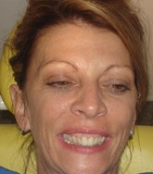 **Ms. Christine Hays (Bahamas)**

We were really over- anxious when we chosen to come at Dr. Ajay’s centre for our dental treatments all the way from Canada just by knowing him through his beautifully designed website but we are really thankful to Dr. Ajay, Dr. Sunita and their team for how nicely they did our full mouth rehabilitation with dental implants and the beautifully looking metal free zerconia caps over them. We are really surprised to the kind of world standard advanced dental treatments they are doing here at very affordable cost. We will now recommend everybody in our country to come this centre for their treatments. Thank you very much for giving us beautiful and confident smile.

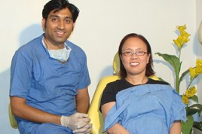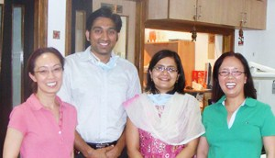

**Ms. Thu Duong & yen Duong (Canada)**

I had the breast cancer problem and my oncologist in USA suggested me to get off all of my porcelain fused to metal bridges and crowns and wear just the removable teeth set to chew the food as the metal my dental crowns is slowly going in my blood stream and can exaggerate the problem of my cancer. I was really prepared to wear the removable teeth set so some of my closed friends suggested me to consult Dr. Ajay for my problem. He discussed with my oncologist and suggested me to get changed my metal ceramic crowns and bridges with metal free zerconia crowns. He solved my worries so professionally and i received a much better looking and safe fixed teeth again. He is very talented, extremely professional and having very well equipped dental set up to give wide range of basic to very advanced dental treatments.

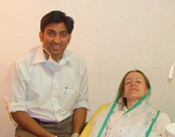  **Ms. Judy (USA)**

I was very much depressed because of large spaces between my upper and lower front teeth

I was not even able to smile openly at my work place and between friends. I consulted Dr. Sunita to correct my smile and I am surprised how nicely she closed all the spaces by putting the metal free veneers and caps over my teeth. Now I can smile very confidently between my friends. I would like to suggest every patient to consult Dr. Sunita and Dr. Ajay for their dental cosmetic problems. Thanks Dr. for giving me confident smile.

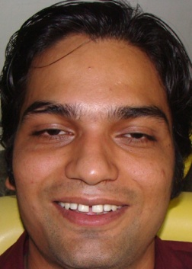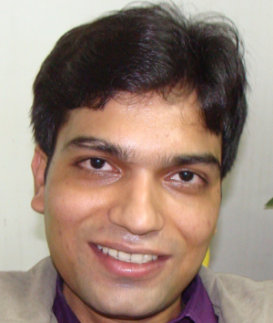 **Mr. A. K. Mishra (Exec. Engineer)**

I have very different story, I got fractured my front teeth in a road side accident just 15 days before my date of marriage. Everybody in my family was just snubbed by looking at my fractured and mobile teeth and huge swelling over the face with upper lip tear. We immediately contacted well known dental center in the city Dr. Ajay Dental clinic & research center. Dr. Ajay immediately called his plastic surgeon for my lip tear repair and Dr. Ajay stabilised my fractured mobile teeth and did the root canal treatments. Dr. Ajay put the metal free aesthetic caps to give the perfect and natural look to my teeth. Dr. Ajay made my teeth even more beautiful what I was having before trauma. He finished all of my treatment before my marriage. I felt very glad when my husband said to me that you have got a very beautiful smile without knowing about the trauma and the treatment. Many Thanks to Dr. Ajay for giving me beautiful smile again.

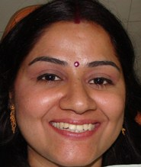 **Mrs. Divya Duvey**

I was fade up the periodontitis in all of my teeth, I lost most of my teeth and rest of teeth were very much mobile with bad breath. I consulted many dentists in the city but everybody suggested the extraction and giving me removable dentures. I was convinced for the extraction of my teeth but I wanted the fixed prosthesis. I read in media a lot about Dr. Ajay for his dental implant techniques to fix the teeth in the gums. I consulted Dr. Ajay and was completely convinced and I am surprised how nicely he inserted implants and gave me all beautifully looking, very strong and fixed teeth. I never heard before about the advanced procedures he did in my case. He is really talented and different from other dentists.

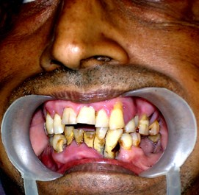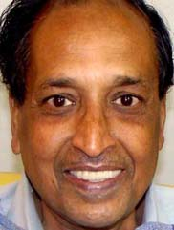 **Mr. Ashok Kumar**

My lower denture was too loose and I was not able to chew anything with this. I couldn’t believe Dr. Ajay fixed my denture by inserting implants in the gums without any pain and now I can chew everything I want with the same denture.

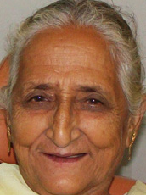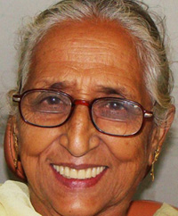 **Mrs. Kunti Devi**