Dr. Ajay’s profile/ achievements

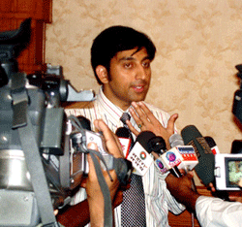
Dr. Ajay presenting his advanced implant techniques in press conference

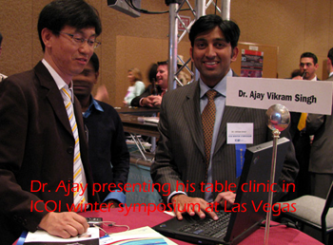

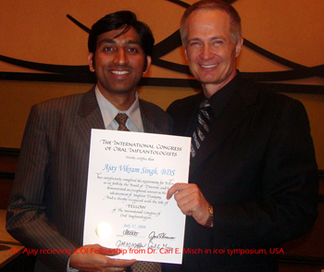
Dr. Ajay receiving icoi fellowship award during icoi international conference at Chicago

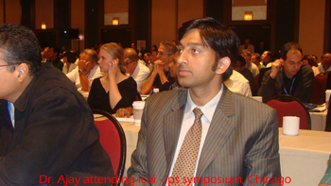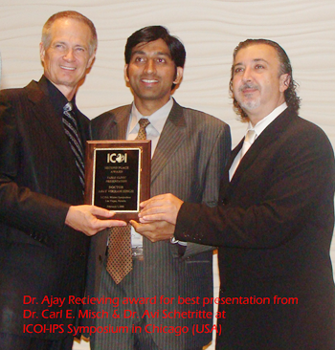

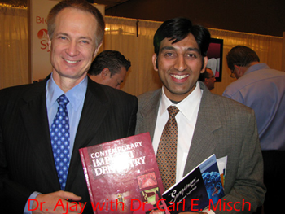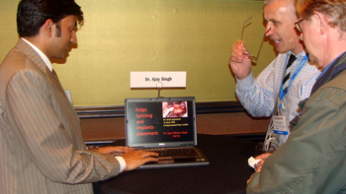
Dr. Ajay presenting table clinic for his newly invented implant techniques at icoi conference at Chicago (USA)

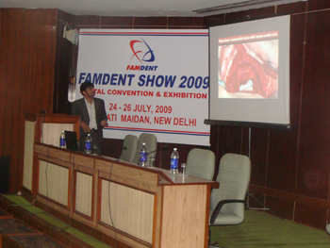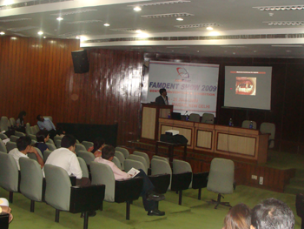
Dr. Ajay lecturing as a guest speaker in Famdent conference at New Delhi
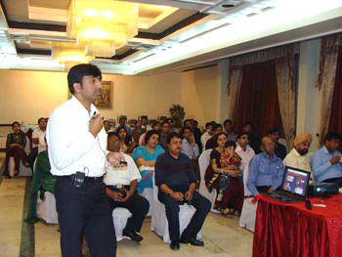
Dr. Ajay lecturing as a guest speaker in work shop of Indian dental association

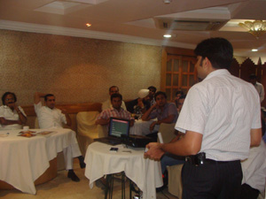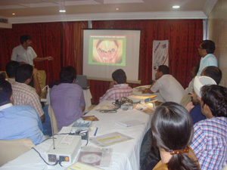
Dr. Ajay lecturing during his 3 days implant training course

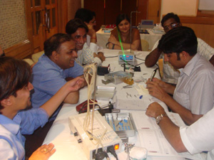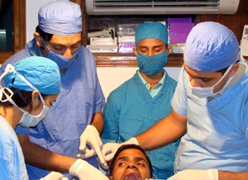
Dr. Ajay giving dental implant training to the dentists

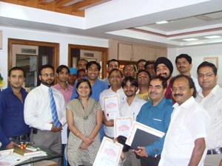
Group of the dentists after receiving 3 days dental implant training at Dr. Ajay’s center

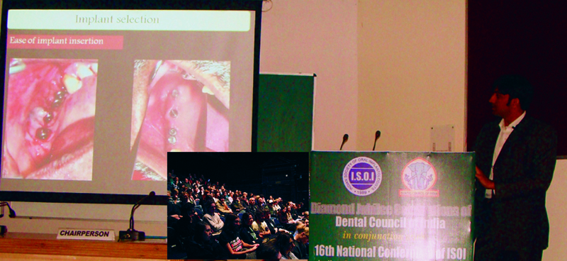
Dr. Ajay lecturing as a key note speaker in the international conference of Indian society of oral implantology and diamond jubilee of dental council of India at New Delhi (attendees in inset)

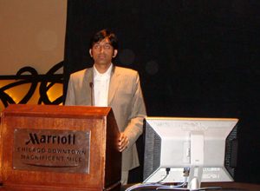
Dr. Ajay lecturing as a guest speaker in icoi conference at Chicago (USA)

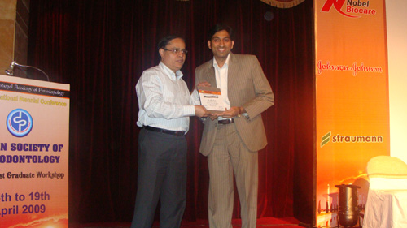
Dr. Ajay receiving award from Dr. Anil Kohli, president of dental council of India for his achievements in dentistry.

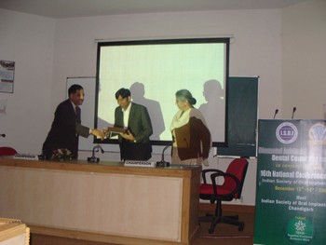
Dr. Ajay receiving award of appreciation at isoi conference, Chandigarh

